**PROJECT USECASE DIAGRAM:**

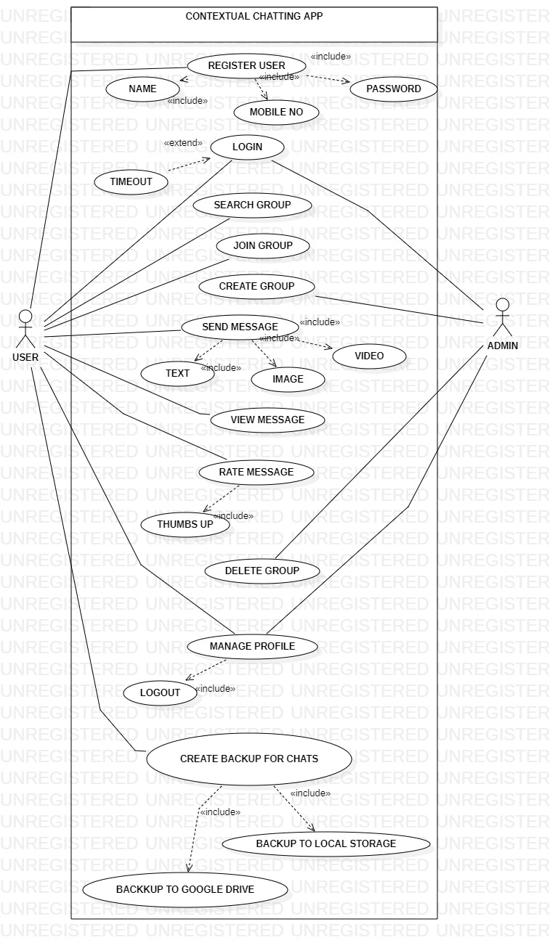

**Use case UC1: Send Message**

**Brief use case:**

In this use case the user can send message to group that he/she joined. For this user select group of its choice and type message in the specified field and then click on send icon. To send message successfully, user must have valid internet connection. The sender message may be text message, picture or video. User will be able to send message at any time.

**Fully addressed use case:**

|  |  |
| --- | --- |
| Use case name | Send message |
| Scope | Contextual chatting app |
| Level | User goal |
| Primary actor | User |
| Stakeholder and interest | * Users: Users will have a new user to discuss queries and problems regarding any respective matter. |
| Precondition | * The user must be already registered user to send message. * The user must have stable internet connection to send message. |
| Success guarantee (post condition) | Message must be delivered and shown to another user if he/she has stable internet connection. |
| Main success scenario | 1. User select group of its choice to send message in it. 2. User type the message in the specified type area and click on send icon. 3. Message may include text message, image or video. 4. Message will be send to other group members if user have valid internet connection. |
| Exception | * User must have account to send message to another user. * User cannot be able to send message if he has some connection issues. |
| Special requirement | User must joined group to send message in group. Also valid connection to send message successfully. |
| Technology and data variation list | Internet connection. |
| Frequency of occurrence | Infinity |
| Miscellaneous |  |

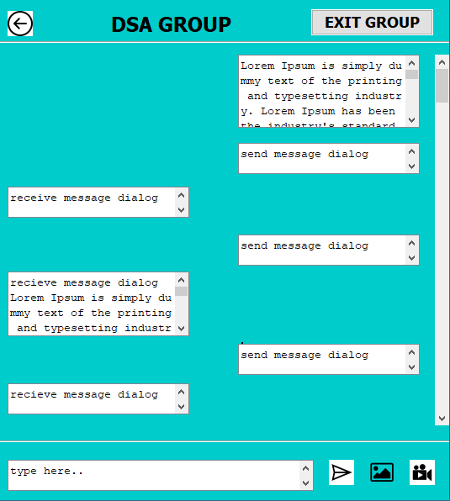

**Use case UC2: View Messages:**

**Brief use case:**

In this use case the user can view messages in group that he/she joined. For this user must select a specific group at a time to view all the messages in it and there is no need of internet connection to view messages. The view message may be text message, picture or video. User can see any message at any time.

**Fully addressed use case:**

|  |  |
| --- | --- |
| Use case name | View message |
| Scope | Contextual chatting app |
| Level | User goal |
| Primary actor | User |
| Stakeholder and interest | * Users: Users will have a new user to discuss queries and problems regarding any respective matter. |
| Precondition | * The user must be already registered user to receive message. * There is no need of stable internet connection to view messages |
| Success guarantee (post condition) | Message must be shown to another user either he has internet connection or not. |
| Main success scenario | 1. The user can select group of its own choice to view messages in it. 2. User can see all the previous messages if he has not valid connection currently. 3. Message may include text message, image or video. |
| Exception | * User must have account to view message from another users. * User can be able to view message if he has some connection issues. |
| Special requirement | User must joined group to view message in group. |
| Technology and data variation list | Internet connection. |
| Frequency of occurrence | Infinite |
| Miscellaneous |  |

